**Project Design Phase-II**

**Data Flow Diagram & User Stories**

|  |  |
| --- | --- |
| Date | 27 June 2025 |
| Team ID | LTVIP2025TMID48224 |
| Project Name | **ToyCraft Tales: Tableau's Vision into Toy Manufacturer Data** |
| Maximum Marks | 4 Marks |

**Data Flow Diagrams:**

A Data Flow Diagram (DFD) is a traditional visual representation of the information flows within a system. A neat and clear DFD can depict the right amount of the system requirement graphically. It shows how data enters and leaves the system, what changes the information, and where data is stored.

**Example:** [**(Simplified)**](https://developer.ibm.com/patterns/visualize-unstructured-text/)

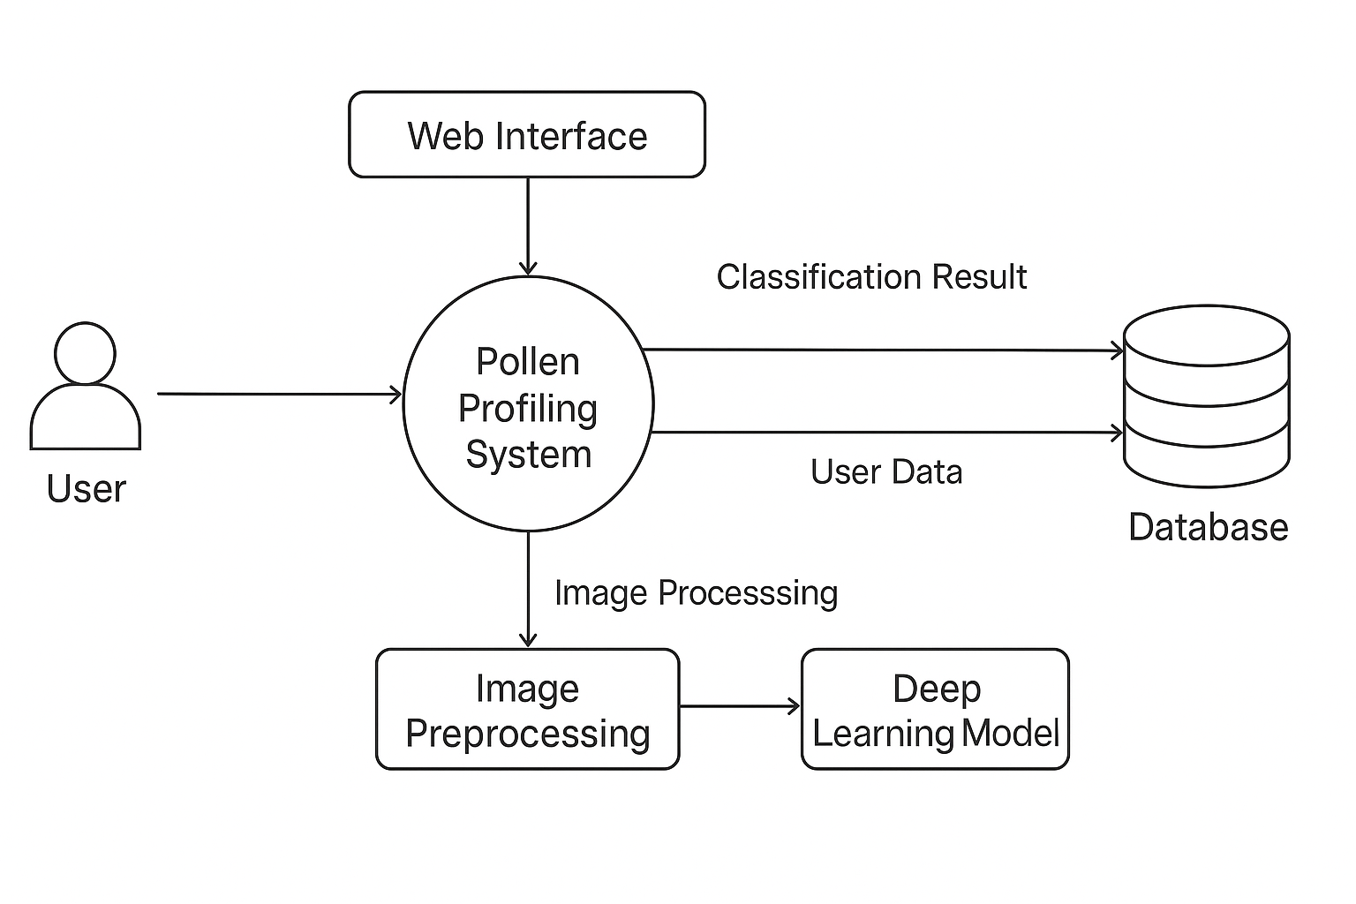

**User Stories**

Use the below template to create product backlog and sprint schedule

| **Sprint** | **Functional Requirement (Epic)** | **User Story Number** | **User Story / Task** | **Story Points** | **Priority** | **Team Members** |
| --- | --- | --- | --- | --- | --- | --- |
| Sprint-1 | Data Collection | USN-1 | As a data engineer, I can collect pollen image data for model training. | 2 | High |  |
| Sprint-1 | Data Loading | USN-2 | As a developer, I can load and visualize the dataset in the pipeline. | 1 | Medium |  |
| Sprint-1 | Data Preprocessing | USN-3 | As a developer, I can handle missing values and clean the data. | 3 | High |  |
| Sprint-1 | Data Preprocessing | USN-4 | As a developer, I can encode and manage categorical variables. | 2 | High |  |
| Sprint-2 | Model Building | USN-5 | As an ML engineer, I can build and train the classification model | 5 | High |  |
| Sprint-2 | Model Evaluation | USN-6 | As an ML engineer, I can test and validate the performance of the model | 3 | High |  |
| Sprint-2 | UI Development | USN-7 | As a front-end developer, I can design working HTML pages for deployment | 3 | Medium |  |
| Sprint-2 | Deployment | USN-8 | As a back-end developer, I can deploy the trained model using React. | 5 | High |  |